# COMP3500: Synchronization 6 - Classical Synchronization Problems

**🟊: >85%, 🟊🟊: 70-85%, 🟊🟊🟊: 55-70%, 🟊🟊🟊🟊: 40-55%, 🟊🟊🟊🟊🟊: < 40%**

**Exercise 1:** Can you solve the dining-philosopher problem?Philosophers spend their lives thinking and eating. Occasionally a philosopher tries to pick up 2 chopsticks (one at a time) to eat from bowl. In the case of 5 philosophers, the shared data include:

* Bowl of rice
* Semaphore array chopstick [5]

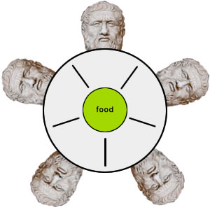

**🟊🟊🟊🟊 Exercise 1.1 (Plickers):** What are the initial values of semaphore array chopstick[5]?

1. chopstick[0]= … chopstick[4] = 0;
2. chopstick[0]= … chopstick[3] = 1; chopstick[4]= 0;
3. chopstick[0]= … chopstick[3] = 0; chopstick[4]= 1;
4. chopstick[0]= … chopstick[4] = 1;

**🟊🟊🟊 Exercise 1.2 (Plickers):** Can you switch the order of the two chopsticks?

1. No
2. Yes
3. Sometimes
4. Depends

**Exercise 2:** What is the problem with the dining-philosopher algorithm? Can you propose any solution?

**Exercise 3:** What is the value item in the following structure? Why we need a lock?

